Date: / /
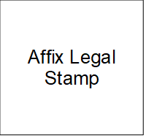
NOC for Ownership Type Change

We the undersigned family member(s) of Mr/Ms. bearing CID have no objection for the change of ownership type from Family Land to Individual Ownership pertaining to Thram no. ,
and Plot ID and Area sq.ft located at
.

Sl No. | Name | CID | Contact no. | Thumb Impression

Witness Detail:
Sl No. | Name | CID | Contact No. | Thumb Impression

Thumb impressions of all the parties to be clearly affixed

